A Story of Implementation using Intel® Skills For Innovation Starter Pack
“Storytelling with Scratch” by Fatma ÜLKER

INTRODUCTION
My name is Fatma ÜLKER and i have a masters degree in education. I am a primary school teacher working in a rural school with a multi-graded classroom. All the students from first grade to fourth grade are taught in one classroom in my school, Sarihaci İlkokulu. I teach all the subjects related to primary school because I am the only teacher of my school. I am a Scientix Ambassador for about a year and trying to implement STEM approach in a multi-graded and rural school with little to none outer support.

IMPLEMENTATION STORY
I have chosen the “Storytelling with Scratch” lesson. I had to make some changes in the lesson plan. Because in my classroom 4 grade is all together. I have 4 first graders, 3 second graders, 7 third grader and 1 fourth grader. Also we have one smart board and 1 desktop computer in our classroom. My students’ mother tongue isn’t English.
On the first day:
I introduced the lesson. Most of the students got excited immediately. I showed the students my favourite game on my phone. It is a simple game with simple instructions. To move your character, you tap on the screen. To open the present that you won, you tap on the present icon, to change the outfit your character wears, you tap on the mirror icon and you swipe among the outfits to choose one of them. To emphasize the algorithm, I repeated “You tap, it takes a step. You tap, it takes a step…”. Students tapped on the screen to move the character, changed the outfit and open the presents.
In the second part of the lesson, instead of showing the recommended video in the starter pack (because it is in a foreign language) I wrote 4 routine tasks on the board and asked them to choose one. Here are the tasks I wrote:
- Brushing your teeth,
- Making a lemonade,
- Getting dressed,
- Enjoying a walk in the park.
They chose “Making a lemonade” and I asked them to direct me to make an imaginary lemonade step by step. They enjoyed to make me do things without me questioning the instructions. While making a lemonade I behaved like a program without them knowing and when they skipped an instruction I froze. They argued about why I am not moving and when they saw the missing steps I continued to follow their instructions. And then I erased the making a lemonade task off the board. While finishing the lesson I asked them to choose one the three task remaining on the board. I assigned them to write the instructions to complete the task they chose.
On the second day:
I asked the students to come to the front of the classroom one-by-one and instruct one of their friend to do the instructions step by step to complete the chosen task. While doing this we argued if any steps were skipped. By the end of the lesson students realized how to write all steps for a task to be completed.
In the second lesson of the second day, I introduced them with Scratch. I showed them the characters’ page, the background page and how to move or make the character say something. The lesson plan in the Starter Pack advises to group the students in pairs but we only have a smart board in our classroom and my students don’t have tablets or smartphones to work with. So I divided the students in almost two equal groups to work on a story. They explored all the characters and backgrounds and asked me if they can draw their own characters. I gave them an extra hour to draw their characters. While arguing on the character they started to create the story.
On the third day:
Since my students don’t have e-mail addresses, I have created one account on Scratch with the e-mail address of our school. The two groups both worked on the same account on different projects in turns. First group wrote a story about a rabbit, a wolf and a hedgehog. They named the story “Tavşanın Olayı (The Event of the Rabbit)”. The second group wrote a story about a witch and a man who lies and the witch punishes the man. They named the story “Cadı ve Adam (The Witch and The Man)”. Their stories can be seen on:
https://scratch.mit.edu/users/Sarihaciilkokulu/
This activity was the most time consuming one in all the activities. Although our stories were short, each story took a lesson to get into the Scratch.
IMPACT
Until this activity I only taught my students coding via cut and glue activities. I have used the activities from the code.org website. Our smart board was installed at the beginning of this year and until this year we didn’t have a chance to work on a computer. We also have a desktop computer in our classroom but it is older than all of my students so working with it was impossible. Therefore, this implementation has had an eye-opening effect for my students. They learned a little coding and saw that they can be a coder and make their own game one day. But on the other hand students saw that coding is a work that requires patience. Some students enjoyed the designing the characters and we talked about the importance of that part. Students also noticed that both girls and boys can be successful at coding.

RECOMMENDATIONS FOR IMPLEMENTATION
I made a list of my recommendations for implementations in schools which are in rural areas and/or have limited technological opportunities.
- Some students aren’t interested in coding, so educators must direct them to drawing or writing part of the lesson.
- Educators must be open minded about going out of the lesson plan.
- Younger students will lost their interest at some point while working with the older students, so educator can use this opportunity to give them extra tasks, such as controlling the written story or typing the dialogues of the characters on the keyboard. This will allow them to improve their language skills.
- A pre-implementation preparation process will help the students to improve their developing algorithm skills. I liked the instruction writing process most because all students were able to write instructions. Younger students wrote about 5-6 instruction and the older ones wrote 10-14 instruction on a routine task.

IMPORTANT NOTE
Here are the images of implementation activities are needed. The permissions to take photograph of the students are taken from the parents.

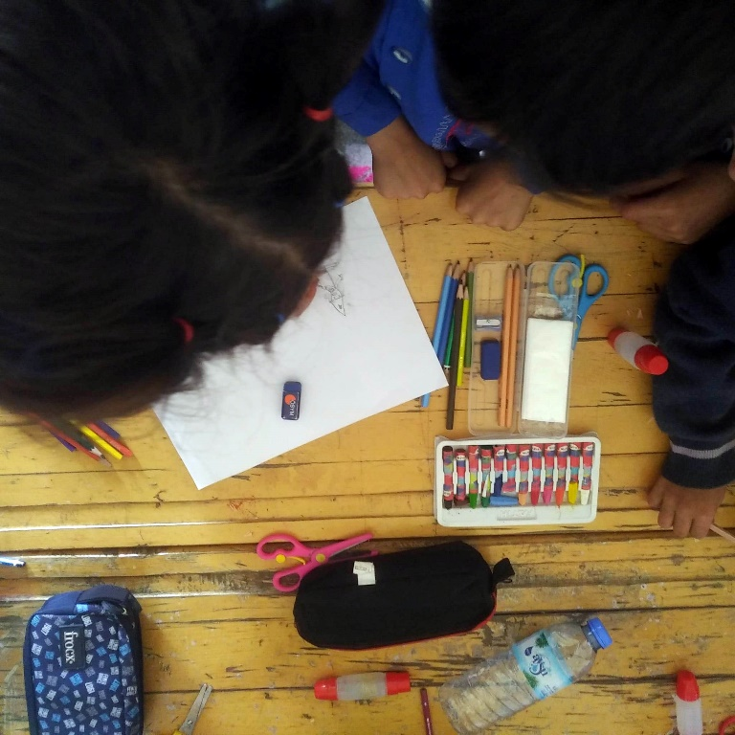
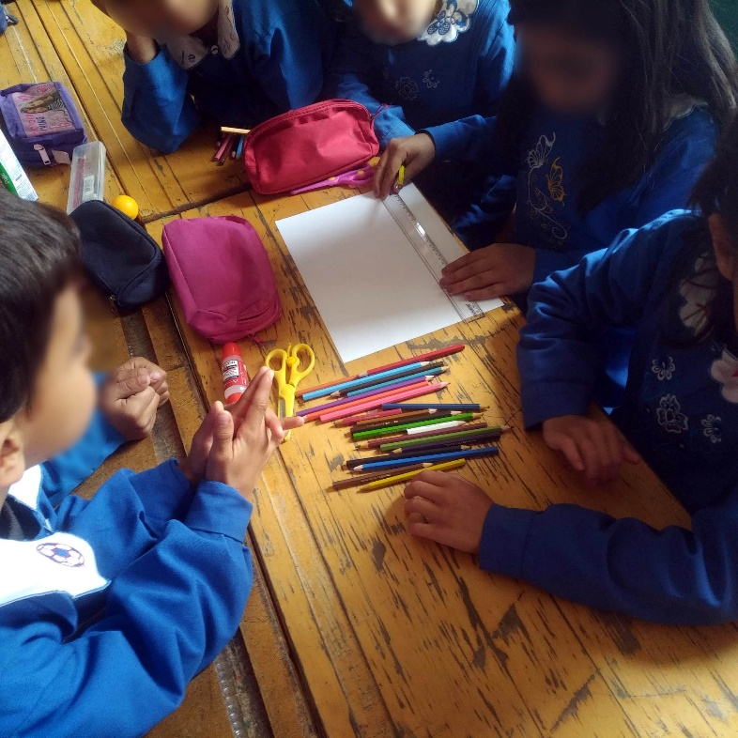
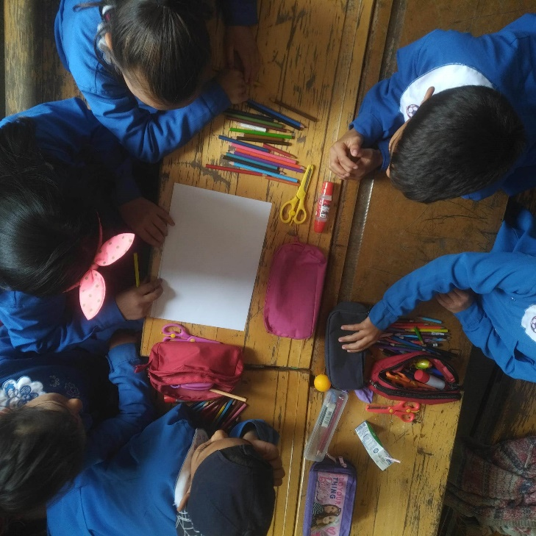
Students are drawing their own characters:

Students are instructing their friends on a daily routine:

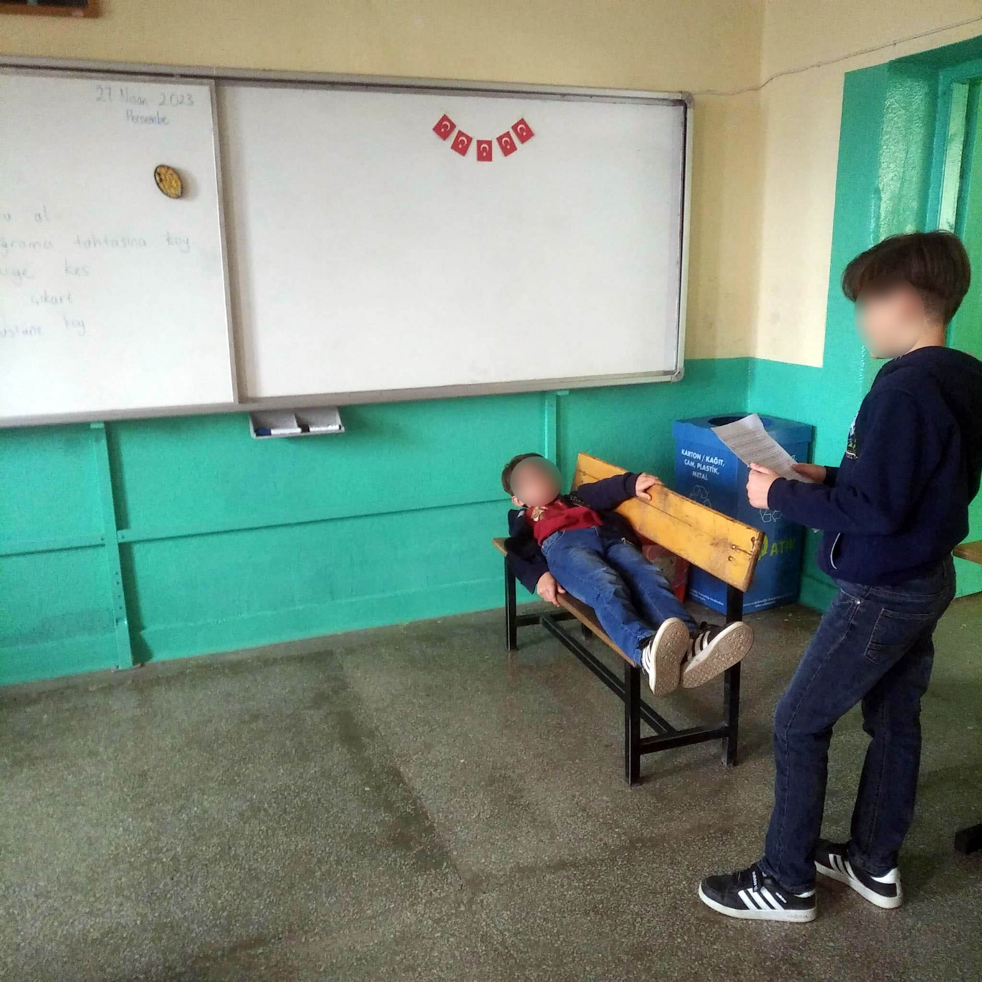

Students are looking at characters and backgrounds at Scratch:
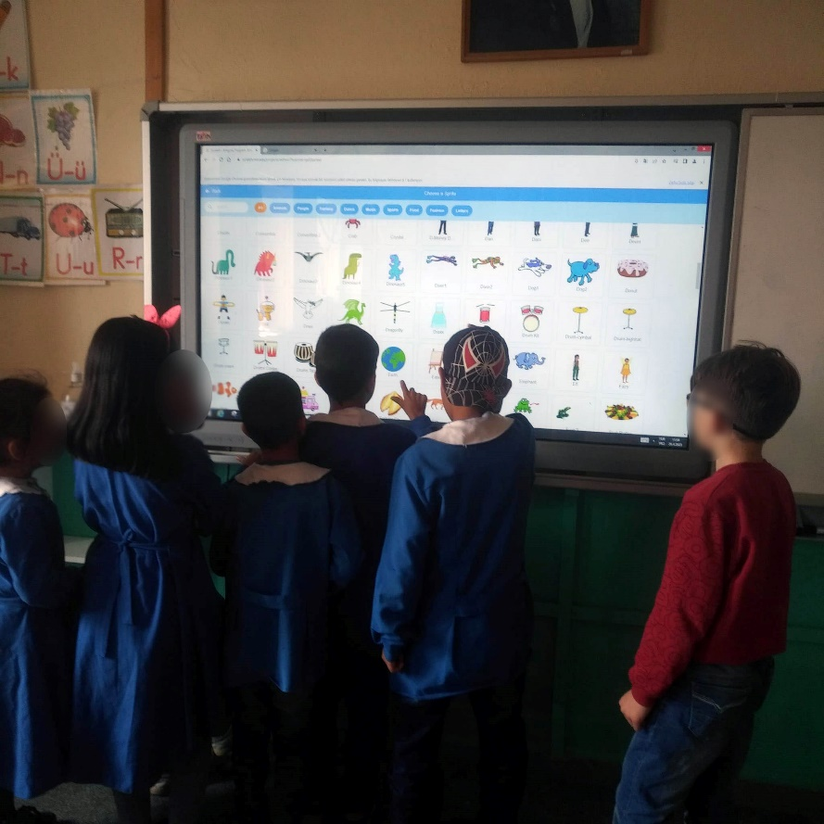

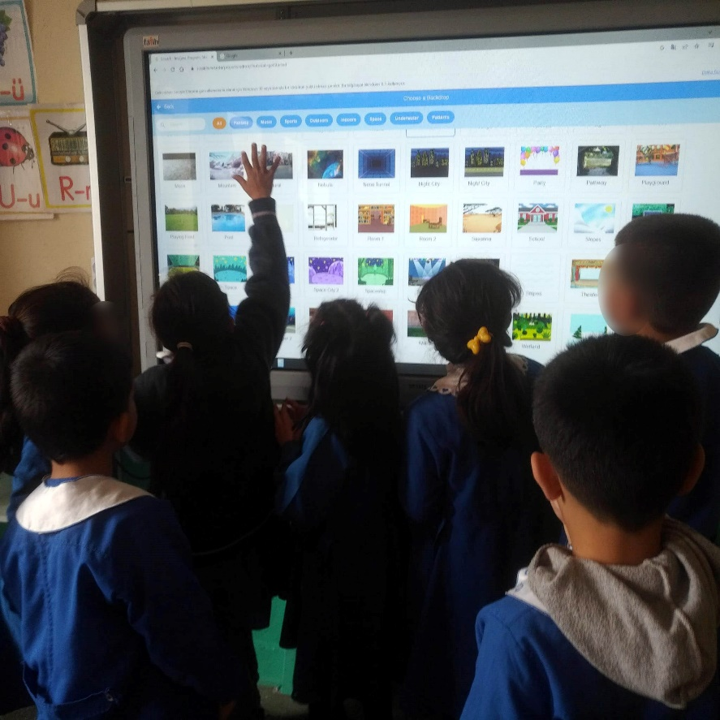

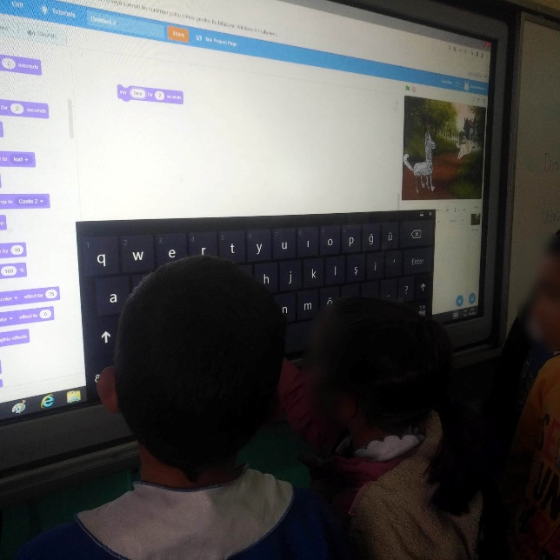
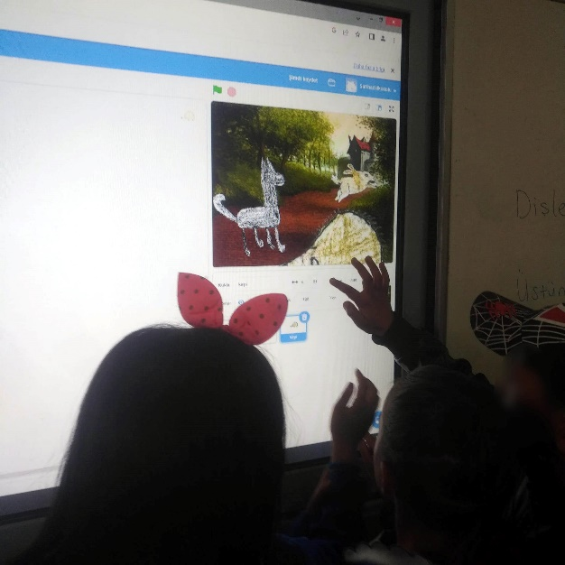
Students are working on their stories at Scratch:
